EMERGENCY CONTACT LIST
Keep this list in a highly visible place for babysitters, family members, and quick reference.
Family Name: ____________________________ Last Updated: ____/____/____

EMERGENCY SERVICES
Service | Phone Number | Notes
Police / Fire / Medical Emergency | 911 | Life-threatening emergencies
Poison Control Center | 1-800-222-1222 | Toxic exposure, swallowed poison
Animal Poison Control (ASPCA) | (888) 426-4435 | Pet toxic exposure
Local Police (Non-Emergency)
Local Fire (Non-Emergency)

HOUSEHOLD INFORMATION (For dispatchers & babysitters)
Information Needed | Details
Home Address (For 911):
Gate Code / Key Location:
Known Allergies in Home:
Major Medical Conditions:

PRIMARY CONTACTS (Family, Friends, Neighbors)
Name | Relationship | Cell Phone | Work / Alt Phone

MEDICAL CONTACTS
Doctor / Facility | Phone Number | Address / Notes
Primary Care Doctor
Pediatrician
Dentist
Hospital / Urgent Care
Pharmacy

UTILITIES & HOME SERVICES
Service / Company | Phone Number | Account # / Notes
Electricity
Water
Gas / Heating
Internet / Provider
Towing / Roadside
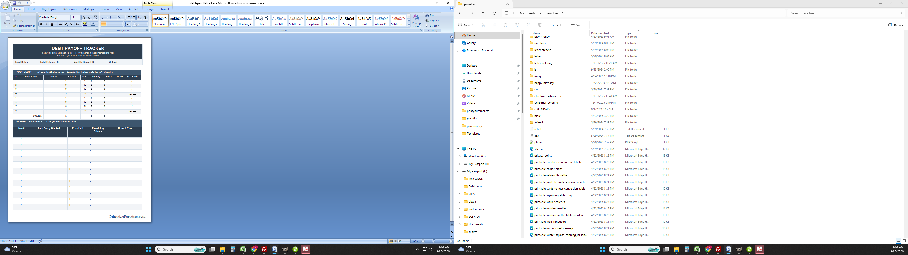
PrintableParadise.com

